

DATA STRUCTURES AND ALGORITHM
23CSE203
LAB MANUAL

SUBMITTED BY
NAME | BIJIVEMULA SHANMUKHASAI
ROLL NO | AV.SC.U4CSE25021
YEAR/SEM/SECTION | 2nd YEAR /SEM-3/CSE A
CREDITS | 05

SUBMITTED TO | DR. RAJ KUMAR BATCHU
DESIGNATION | ASST.PROFFESSOR (Sl. Grade)
DEPARTMENT | SCHOOL OF COMPUTING

INDEX

SNO (lab) | PROGRAM | PAGE NO
Lab 1 | WEEK-1:1a. Recursive countdown from n to Launch.  1b. Recursive calculation of compound growth factor.  1c. Recursive search for employee ID in list.  1d. Recursive factorial calculation for parcel arrangements.  1e. Recursive Fibonacci series generation. | 3-9
2 | WEEK-2: 2a. Python program to perform linear search on the given input. 2b. Python program to perform binary search on the given input. 2c. Verify by taking sorted array and unsorted array as an input.
3 | WEEK -3: 3a. Python program to perform bubble sort on the given input. 3b. Python program to perform insertion sort on the given input. 3c. Python program to perform selection sort on the given input. 3d. Python program to perform merge sort on the given input. 3e. Python program to perform quick sort on the given input
4 | WEEK-4: 4a. Write the python program to implement a single linked list which could perform the below operations,by taking an input from the user.  4b. Write the python program to implement a double linked list which could perform the below operations,by taking an input from the user.  4c. Write the python program to implement a circular linked list which could perform the below operations,by taking an input from the user.

5

LAB -1
1)AIM: A rocket launch system displays a countdown before launch. Instead of using a loop, implement the countdown using recursion. Write a recursive Python program to display a countdown from n to 1, followed by “launch”.
PROGRAM:
def launch(n):
for i in range(n,-1,-1):
if i==0:
print("launch"):
else:
print(i)
n=int (input ("enter no. of seconds to launch:"))
launch(n)
OUTPUT:
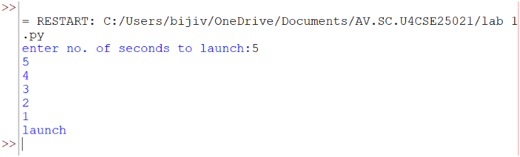
EXPLANATION:
This program displays a countdown from n to 1 and finally prints 'launch'. Although the aim mentions recursion, the given code uses a loop.

ERROR TABLE:
ERROR | CAUSE | SOLUTION
Indentation Error | Incorrect indentation | Align blocks properly
Name Error | Variable not defined | Define before use
Value Error | Non-integer input | Enter a valid integer

2)AIM: Banks calculate the growth of an investment using compound interest. The formula requires calculating powers. Which can be implemented recursively. Write a recursive program to calculate p^n(power), where p=principal growth factor, n= number of years.
PROGRAM:
def intrest(p,n):
if n==0:
return 1
else:
return p*intrest(p,n-1)
n=int(input("enter no.of years:"))
p=int(input("enter a number:"))
res=intrest(p,n)
print(res)
OUTPUT:
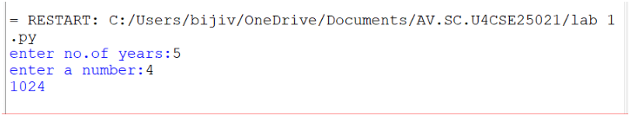

EXPLANATION:
This program recursively calculates p^n by multiplying p until n becomes 0.
ERROR TABLE:
ERROR | CAUSE | SOLUTION
Recursion error | Very large value of n | Reduce input
Name Error | Wrong function/variable name | Check spelling
Value Error | Non-integer input | Enter a valid integer

3)AIM: An HR department stores employee ID’s in a list. Develop a recursive program to search for a given employee ID. Write a recursive function to search for an employee ID in a list.
PROGRAM:
def search(m)
key=m
for i in range(n-1):
if arr[i]==key:
return i
n=int(input("enter no.of employees to add:"))
arr=[]
for i in range(n):
a=int(input("enter a value:"))
arr.append(a)
print(arr)
m=int(input("enter a element to search:"))
result=search(m)
if result==-1:
print(“element is not found”)
else:
print("employee id is stored at the index:",result)
OUTPUT:
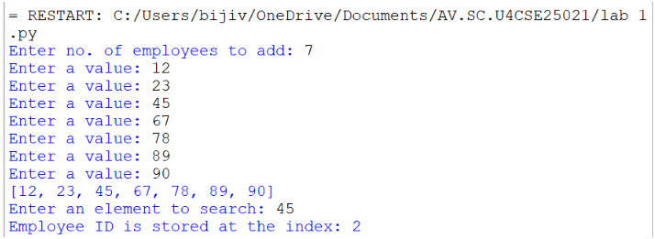
EXPLANATION:
This program searches for an employee ID in a list and returns its index if found.
ERROR TABLE:
ERROR | CAUSE | SOLUTION
Syntax error | Wrong quotes/brackets | Correct syntax
Logic error | Returns None instead of -1 | Return -1 when not found

4)AIM: In a logistics company, the number of possible ways to arrange n different parcels is calculated using the factorial formula(n!). Develop a recursive program to calculate the factorial of a given number.

PROGRAM:
def fact(n):
fact=1
for i in range(1,n+1):
fact=fact*i

return fact
n=int(input("enter a number to find its factorial:"))
result=fact(n)
print(result)
OUTPUT:
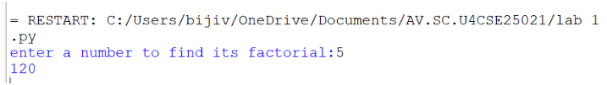

EXPLANATION:
This program calculates the factorial of a number using iteration (not recursion).
ERROR TABLE:
ERROR | CAUSE | SOLUTION
Overflow/large input | Large input value | Give smaller input
Value error | Invalid input | Even integer

5)AIM: Write a recursive Python program to print the first n terms of the Fibonacci series.

PROGRAM:
def fib(n):
if n==0:
return 0
elif n==1:
return 1
else:
return fib(n-1)+fib(n-2)

n=int(input("enter no of terms:"))
if n<=-1:
print("invalid input")
else:
for i in range(n):
print(fib(i),end=" ")
OUTPUT:
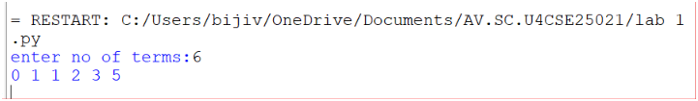
EXPLANATION:
The program uses recursion to generate Fibonacci numbers. fib (0)=0 and fib (1) =1 are the base cases. For every other term, fib(n)=fib(n-1) + fib(n-2). The loop prints the first n terms.

ERROR TABLE:
ERROR | CAUSE | SOLUTION
Recursion error | Large value of n | Use iteration
Invalid input | Negative value of n | Validate input
Slow execution | Repeated recursive calls | Use dynamic programming

PROGRAM | TIME COMPLEXITY | SPACE COMPLEXITY | REASON
1. countdown to launch |  |  | The program uses a loop that prints from n to 0 once.
  O(n)
  O (1)
2. Power calculation |  |  | One recursive call is made for each value of n—the recursion stack stores n calls.
  O(n)
  O(n)
3. Employee ID search |  |  | The program performs a linear search through the list.
  O(n)
  O (1)
4.Factorial |  |  | The program calculates factorial using a loop from 1 to n.
  O(n)
  O (1)
5. Fibonacci series
  O(2ⁿ)
  O(n)
  Each function call creates two additional recursive calls, leading to exponential time complexity. The recursion stack reaches depth n.

Lab 2
1.AIM: Write a program to perform linear search on a given input.
PROGRAM:
def linear_search(arr,key):
for i in range(len(arr)):
if arr[i]==key:
return i
return -1

n = int(input("Enter no. of elements:"))
arr=[]
print("Enter the elements:")
for i in range(n):
arr.append(int(input()))
key=int(input("Enter element to search:"))
result=linear_search(arr,key)
if result!=-1:
print("Element found at index",result)
else:
print("Element not found.")
OUTPUT:
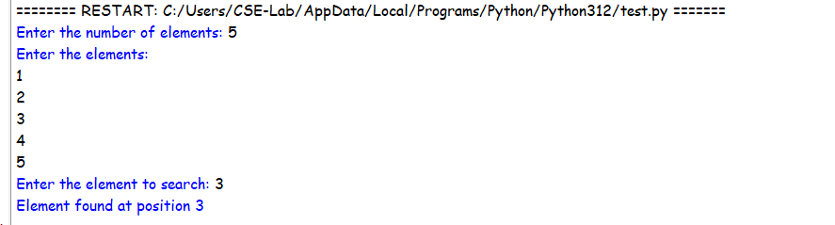
EXPLANATION:
- The linear_search() function checks each element of the list one by one and compares it with the given key.
- If the key is found, its index is returned; otherwise, the function returns -1.
- The program takes the array and search element as input and displays whether the element is found.
ERROR TABLE:
S.no. | Errors | Rectification
1. | ValueError occurs if a non-integer value is entered when int(input()) is used. | Enter only integer values for the number of elements and array elements.
2. | TypeError may occur if len(arr) is used on a variable that is not a list. | Make sure arr is initialized as a list using arr = [] and elements are appended to it.

2.AIM: Write a Python program to perform binary search on the given input. Verify by taking sorted array and unsorted array as input.
PROGRAM:
def binary_search(arr,key):
low=0
high=len(arr)-1
while low<=high:
mid=(low+high)//2
if arr[mid]==key:
return mid
elif arr[mid]<key:
low=mid+1
else:
high=mid-1
return -1

n = int(input("Enter no. of elements:"))
arr=[]
print("Enter the elements:")
for i in range(n):
arr.append(int(input()))
key=int(input("Enter element to search:"))
result=binary_search(arr,key)
if result!=-1:
print("Element found at index",result)
else:
print("Element not found.")
OUTPUT:
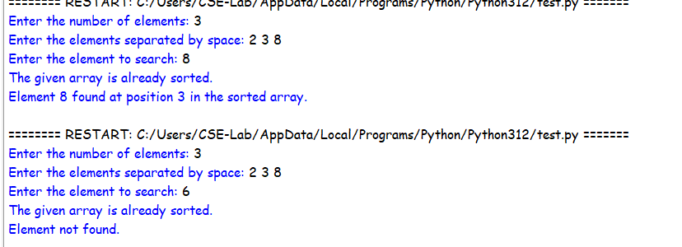
3.PROGRAM:
def binary_search(arr,key):
low=0
high=len(arr)-1
while low<=high:
mid=(low+high)//2
if arr[mid]==key:
return mid
elif arr[mid]<key:
low=mid+1
else:
high=mid-1
return -1

n = int(input("Enter no. of elements:"))
arr=[]
print("Enter the elements:")
for i in range(n):
arr.append(int(input()))
if arr==sorted(arr):
print("\n The input list is already sorted.")
else:
print("\n The input list is not sorted.")
print("Sorting the list...")
arr.sort()
print("Sorted list.",arr)
key=int(input("Enter element to search:"))
result=binary_search(arr,key)
if result!=-1:
print("Element found at index",result)
else:
print("Element not found.")

OUTPUT:

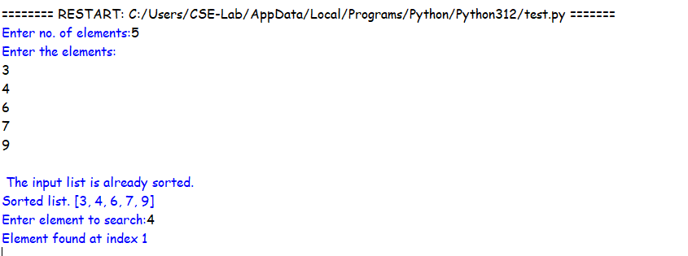
EXPLANATION:
- The binary_search() function repeatedly divides the sorted list into two halves and compares the middle element with the search key.
- If the middle element is smaller than the key, the search continues in the right half; otherwise, it searches the left half.
- The second program verifies whether the input is sorted and sorts it using arr.sort() if necessary before performing binary search.

ERROR TABLE:
S.no. | Errors | Rectification
1. | Binary search may give an incorrect result if the input array is unsorted. | Check whether the array is sorted and use arr.sort() before calling binary_search().
2. | IndexError can occur if mid is calculated or the low/high boundaries are modified incorrectly. | Initialize low = 0, high = len(arr) - 1 and update them as low = mid + 1 or high = mid - 1.

LAB-3
AIM: 3a. Write a python program to sort the elements using a bubble sort technique. Take the input elements from the user.
Program:
n = int(input("Enter the number of elements: "))
arr = []
print("Enter the elements:")
for i in range(n):
arr.append(int(input()))
for i in range(n - 1):
for j in range(n - i - 1):
if arr[j] < arr[j + 1]:
arr[j], arr[j + 1] = arr[j + 1], arr[j]
print("Elements after Bubble Sort:")
print(arr)
Output:
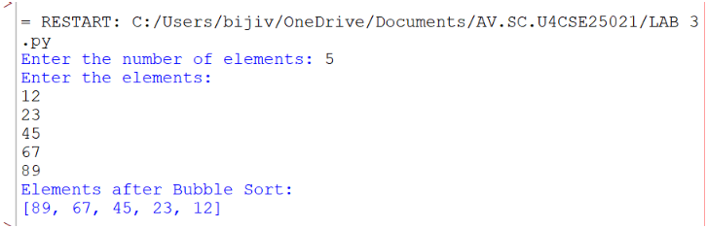
Explanation:
• n = int(input(...)) – Gets the number of elements.
• arr = [] – Creates an empty list to store elements.
• for i in range(n) – Takes n elements as input.
• arr.append(...) – Adds each element to arr.
• for i in range(n - 1) – Performs Bubble Sort passes.
• for j in range(n - i - 1) – Compares adjacent elements.
• if arr[j] < arr[j + 1] – Checks if the current element is smaller.
• arr[j], arr[j + 1] = ... – Swaps the elements to sort in descending order.
• print(arr) – Displays the sorted list.
Error Table:
S.NO | Error Obtained | Rectification
1. | Sorting Order Error – Using > instead of < in the if condition changes the order to ascending. | Use if arr[j] < arr[j + 1]: for descending order.

AIM: 3b.Write a python program to sort the elements using a insertion sort technique. Take the input elements from the user.
Program:
def insertion_sort(arr):
n = len(arr)
for i in range (1,n):
key = arr[i]
j = i - 1
while j >= 0 and arr[j] > key:
arr[j+1] = arr[j]
j = j - 1
arr[j+1] = key
return arr
n = int(input("Enter the number of elements: "))
arr = []
print("Enter the elements:")
for i in range(n):
element = int(input())
arr.append(element)
result = insertion_sort(arr)
print("Elements after Insertion Sort:")
print(result)
Output:
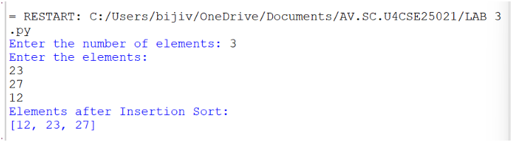
Explanation:
• n = len(arr) – Gets the list size.
• for i in range(1, n) – Selects elements from the second position.
• key = arr[i] – Stores the current element.
• j = i - 1 – Sets the previous index.
• while j >= 0 and arr[j] > key – Compares previous elements with key.
• arr[j + 1] = arr[j] – Shifts larger elements right.
• arr[j + 1] = key – Inserts key in the correct position.
• return arr – Returns the sorted list.
• result = insertion_sort(arr) – Calls the function.
• print(result) – Displays the sorted list.
ERROR TABLE:
S.NO | Error Obtained | Rectification
1. | Insertion Error – Placing key at the wrong index. | Use arr[j + 1] = key after shifting elements.
2. | Function Call Error – Not calling insertion_sort(arr) correctly. | Pass the input list arr to the function.

AIM: 3c.Write a python program to sort the elements using a selection sort technique. Take the input elements from the user.
Program:
def selection_sort(arr):
n=len(arr)
for i in range(n-1):
min_index=i
for j in range (i+1,n):
if arr[j]<arr[min_index]:
min_index=j
arr[i],arr[min_index]=arr[min_index],arr[i]
return arr
n=int(input("Enter the number of elements: "))
arr=[]
print("Enter the elements:")
for i in range(n):
element=int(input())
arr.append(element)
result=selection_sort(arr)
print("Elements after Selection Sort:")
print(result)
Output:
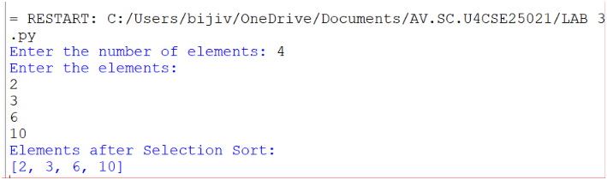
Explanation:
• def selection_sort(arr) – Defines the Selection Sort function.
• n = len(arr) – Gets the number of elements in arr.
• for i in range(n-1) – Performs sorting passes.
• min_index = i – Assumes the first element is the smallest.
• for j in range(i+1,n) – Checks the remaining elements.
• if arr[j] < arr[min_index] – Finds the smallest element.
• arr[i], arr[min_index] = ... – Swaps the smallest element into position.
• return arr – Returns the sorted list.
• result = selection_sort(arr) – Calls the function.
• print(result) – Displays the sorted list in ascending order.

Error Table:
S.NO | Error Obtained | Rectification
1. | Swap Error – Incorrectly swapping the elements. | Use arr[i], arr[min_index] = arr[min_index], arr[i].
2. | Minimum Index Error – Incorrectly assigning min_index. | Use min_index = i.

AIM: 3d.Write a python program to sort the elements using a merge sort technique. Take the input elements from the user.
Program:
def merge_sort(arr):
if len(arr) <= 1:
return arr
mid=len(arr)//2
left=merge_sort(arr[:mid])
right=merge_sort(arr[mid:])
i = j = k = 0
while i < len(left) and j < len(right):
if left[i] <= right[j]:
arr[k] = left[i]
i += 1
else:
arr[k] = right[j]
j += 1
k += 1
while i < len(left):
arr[k] = left[i]
i += 1
k += 1
while j < len(right):
arr[k] = right[j]
j += 1
k += 1
return arr
n = int(input("Enter the number of elements: "))
arr = []
print("Enter the elements:")
for i in range(n):
element = int(input())
arr.append(element)
result = merge_sort(arr)
print("Elements after Merge Sort:")
print(result)
Output:
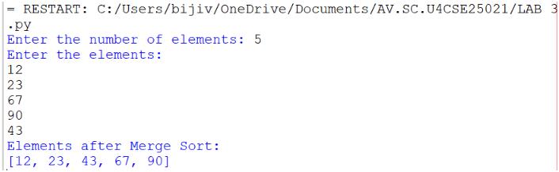
Explanation:
• def merge_sort(arr) – Defines the Merge Sort function.
• if len(arr) <= 1 – Stops when the list has one or no elements.
• mid = len(arr)//2 – Finds the middle of the list.
• left and right – Divide the list into two halves recursively.
• i = j = k = 0 – Initializes the indexes.
• while loops – Compare and merge the elements.
• if left[i] <= right[j] – Selects the smaller element.
• arr[k] – Places the selected element in the list.
Error Table:
S.NO | Error Obtained | Rectification
1. | Index Error – Incorrectly updating i, j, or k. | Increment the appropriate index after each insertion.
2. | Recursion Error – Incorrectly dividing the list. | Use arr[:mid] and arr[mid:].
AIM: 3e.Write a python program to sort the elements using a quick sort technique. Take the input elements from the user.
Program:
def quicksort(a,low,high):
if low < high:
i = low
j = high
pivot = low
while i < j:
while i < len(a) and a[i]<=a[pivot]:
i +=1
while a[j] > a[pivot]:
j = j -1
if i < j:
a[i],a[j] = a[j],a[i]
a[j],a[pivot] = a[pivot],a[j]
quicksort(a,low,j-1)
quicksort(a,j+1,high)
a = list(map(int,input("Enter numbers to sort:").split(" ")))
n = len(a)
quicksort(a,0,n-1)
print("Sorted array:")
print(a)
Output:
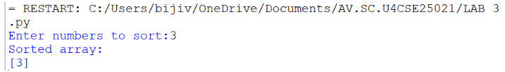

Explanation:
• def quicksort(a, low, high) – Defines the Quick Sort function.
• if low < high – Checks the sorting range.
• i and j – Set left and right positions.
• pivot = low – Selects the first element as pivot.
• while i < j – Performs partitioning.
• Inner while loops – Find elements for swapping.
• a[i], a[j] = ... – Swaps elements.
• a[j], a[pivot] = ... – Places the pivot correctly.
• quicksort() calls – Sort the two partitions.
• input().split() – Takes space-separated numbers.
• print(a) – Displays the sorted array.

Error Table:
S.NO | Error Obtained | Rectification
1. | Pivot Error – Incorrectly selecting the pivot index. | Use pivot = low.
2. | Swap Error – Incorrect swapping of a[i] and a[j]. | Use a[i], a[j] = a[j], a[i].

WEEK-4
AIM: 4a. Write the Python program to implement a single linked list which could perform the following operations by taking input from the user.
Program:
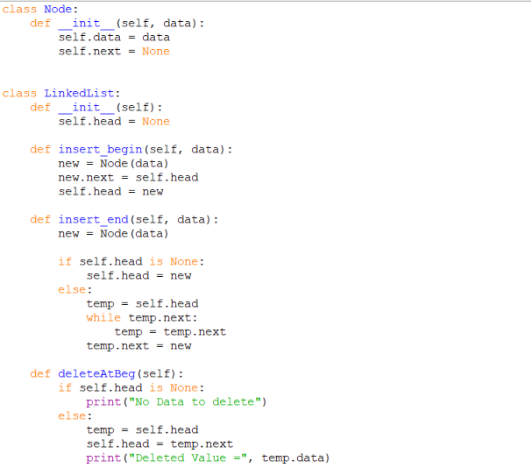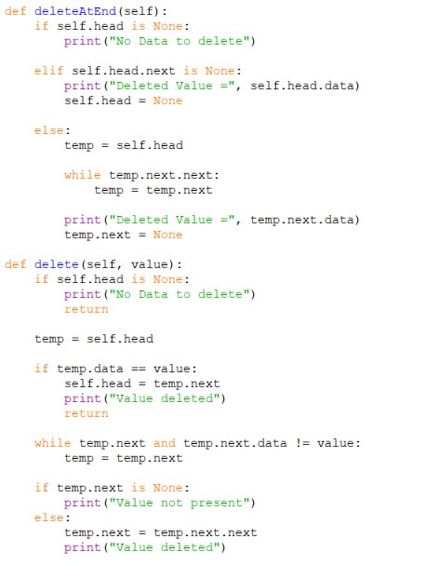
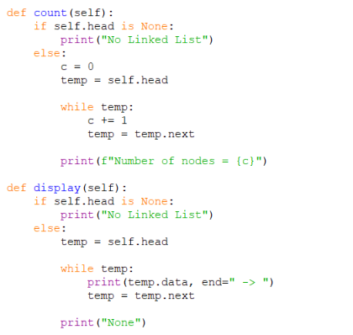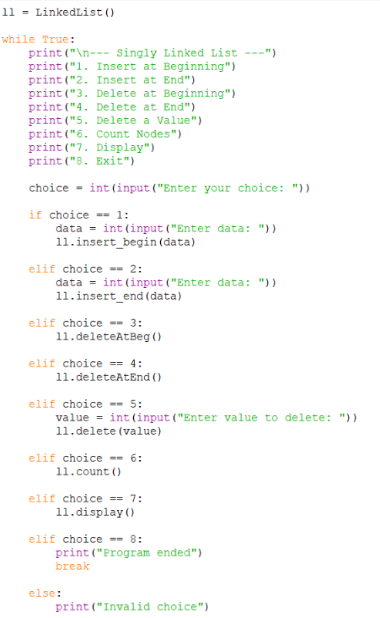
Output:
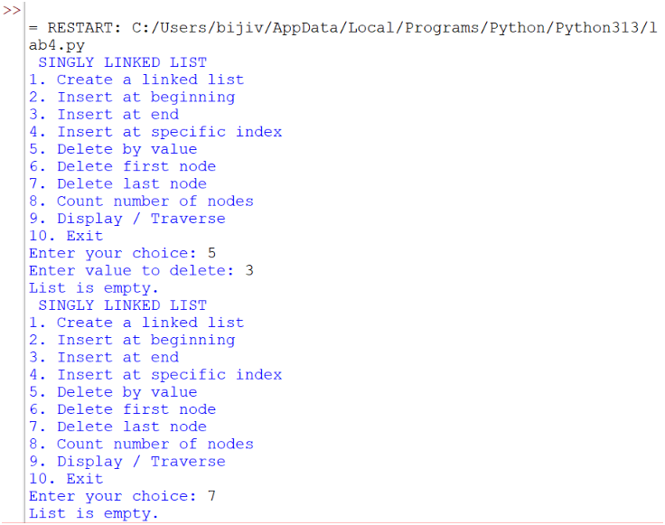
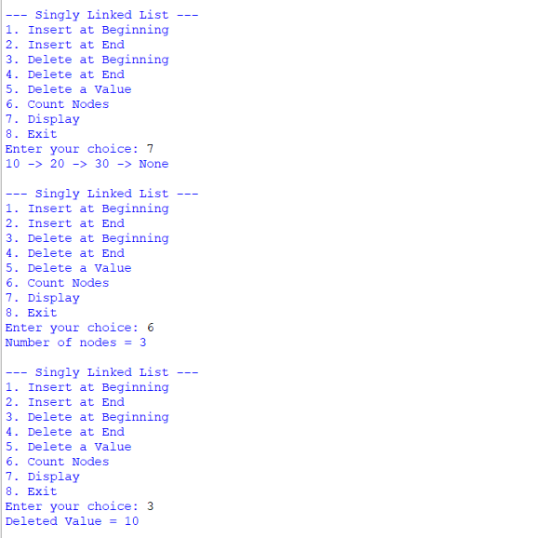

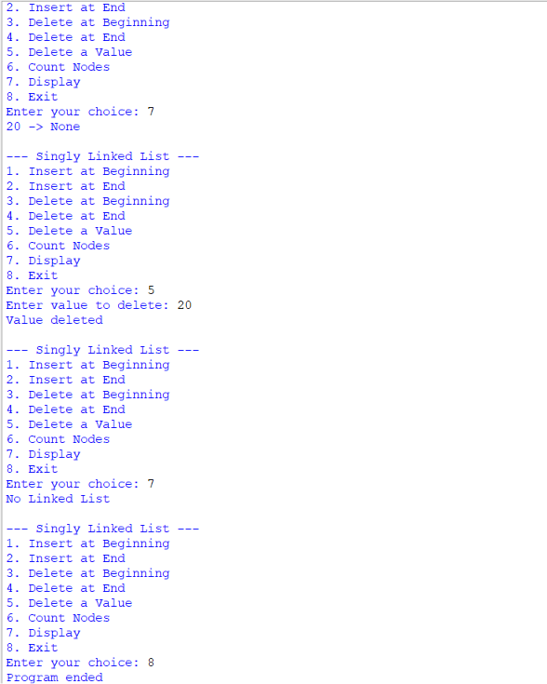

Explanation:
This program implements a singly linked list in Python. Each node contains two parts: data and a next pointer that stores the address of the next node.
- Node class: Creates a node with data and next.
- insert_begin(): Inserts a new node at the beginning of the linked list.
- insert_end(): Inserts a new node at the end of the linked list.
- deleteAtBeg(): Deletes the first node from the linked list.
- deleteAtEnd(): Deletes the last node from the linked list.
- delete(value): Searches for a given value and deletes that node.
- count(): Counts and displays the total number of nodes.
- display(): Displays all node values from beginning to end.
- Main program: Uses a menu so the user can select different linked-list operations until choosing Exit.

Error Table:
S.NO | Error Obtained | Rectification
1. | Error while deleting from an empty list | Check if self.head is None before deletion.
2. | Last node was not deleted correctly | Handle the single-node case and set the previous node's next to None.
3. | Incorrect output while displaying the list | Traverse using while temp: and print each node's data.

PROGRAM | TIME COMPLEXITY |  |  | SPACE COMPLEXITY | REASON
1. Insert at Beginning |  |  |  |  | Directly changes the head.
  O(1)
  O(1)
2.Insert at End |  |  |  |  | Traverse to the last node
  O(n)
  O(1)
3.Delete at Beginning |  |  |  |  | Directly removes the head
  O(1)
  O(1)
4.Delete at End |  |  |  |  | Traverse to the last node
  O(n)
  O(1)
5.Delete by value
  O(n)
  O(1)
  May search the entire list
6.Count Nodes | O(n) |  | O(1) |  | Traverses all nodes
7.Display |  | O(n) | O(1) |  | Traverse all nodes

AIM: 4b. Write a Python program to implement a doubly linked list that performs the operations below by taking input from the user.
Program:
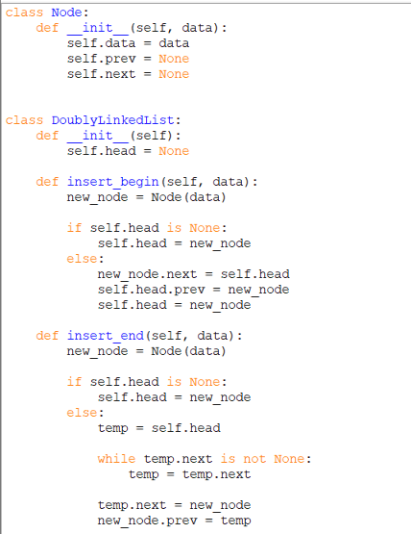
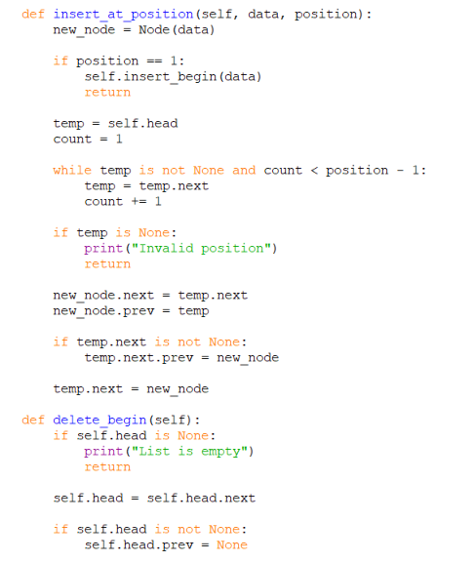
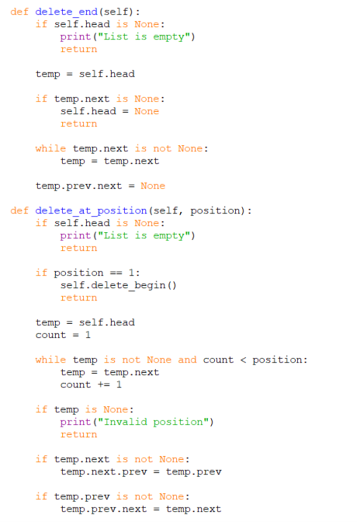
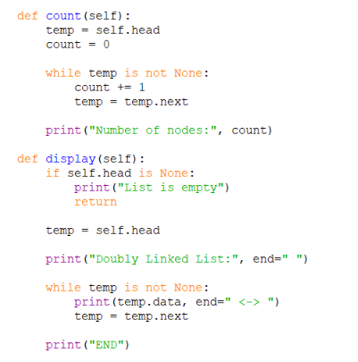

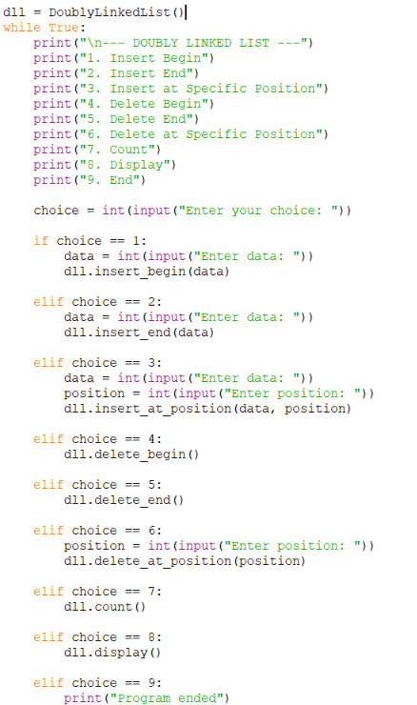

Output:
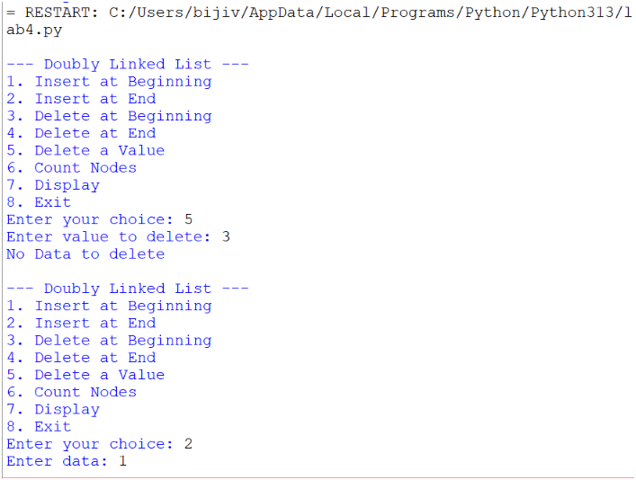

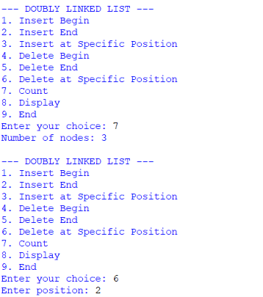
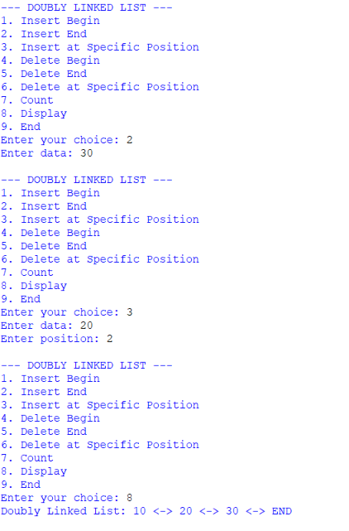

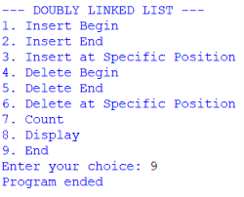
Explanation of Code:
A doubly linked list is a collection of nodes where each node contains data, previous link (prev) and next link (next). The program uses a menu to perform insertion, deletion, counting, and display operations.
- Node: Stores data, prev, and next.
- Head: Points to the first node of the list.
- Insert Begin: Adds a new node at the beginning and updates the links.
- Insert End: Traverses to the last node and adds the new node.
- Insert at Position: Adds a node at the specified position by updating both links.
- Delete Begin: Removes the first node and changes the head.
- Delete End: Removes the last node and sets the previous node's next to None.
- Delete at Position: Removes the specified node and connects its previous and next nodes.
- Count: Traverses the list and counts the number of nodes.
- Display: Traverses and prints all node values.
- End: Stops the program using break.
Error Table:
S.NO | Error Obtained | Rectification
1. | Forgetting to update prev and next links. | Update both links correctly during insertion and deletion.
2. | Deleting a node from an empty list. | Check if self.head is None before deletion.
3. | Entering an invalid position. | Check the position and display “Invalid position”.

PROGRAM | TIME COMPLEXITY |  |  | SPACE COMPLEXITY | REASON
1. Insert at Beginning |  |  |  |  | Directly inserts before head
  O(1)
  O(1)
2.Insert at End |  |  |  |  | Traverse the list to reach the last node.
  O(n)
  O(1)
3.Delete at Beginning |  |  |  |  | Directly removes the first node
  O(1)
  O(1)
4.Delete at End |  |  |  |  | Traverse to the last node
  O(n)
  O(1)
5.Delete by value
  O(n)
  O(1)
  Traverses to the specified position
6.Count Nodes | O(n) |  | O(1) |  | Visits every node to count them
7.Display |  | O(n) | O(1) |  | Visits every node to display the data
AIM: 4c. Write the Python program to implement a circular linked list which could perform the below operations, by taking an input from the user.
Program:
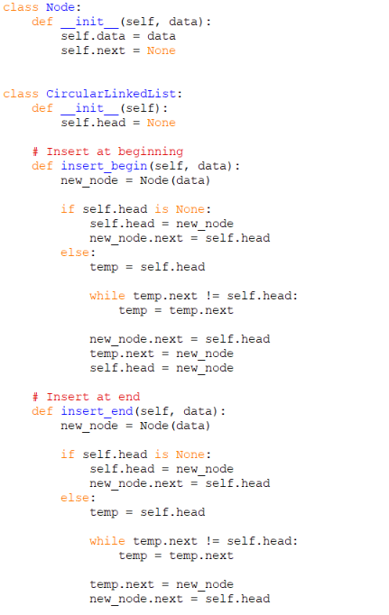
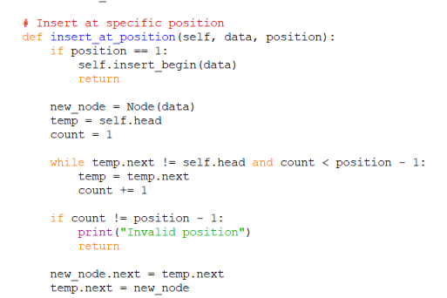
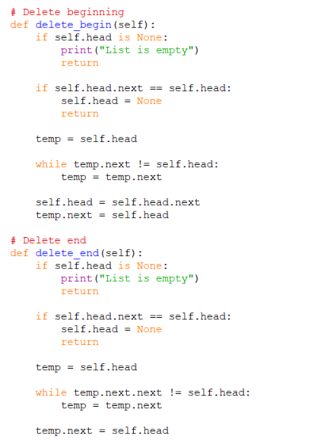
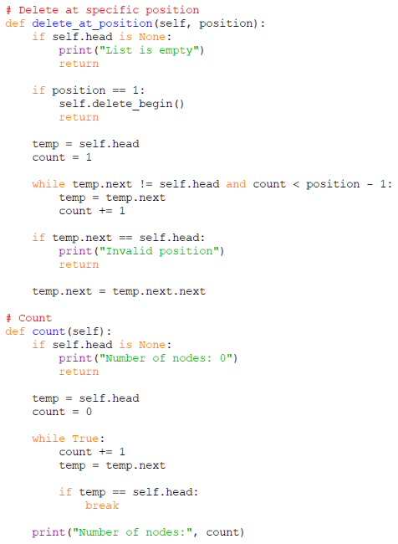
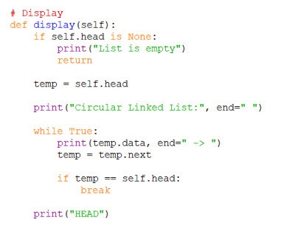
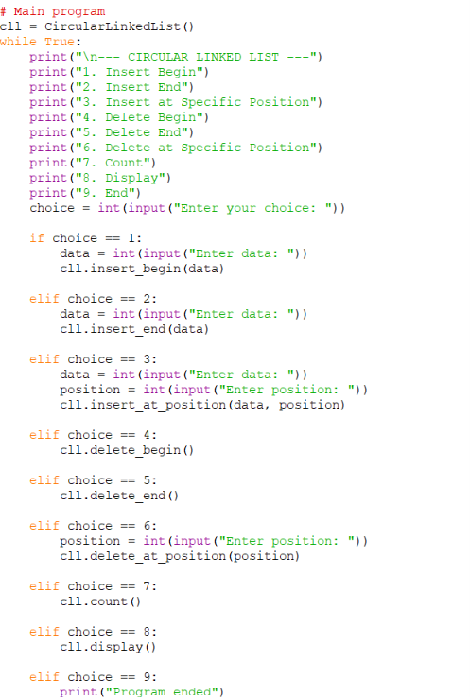

Output:
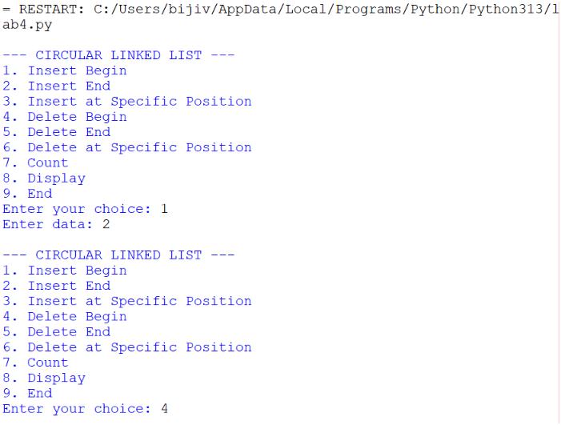
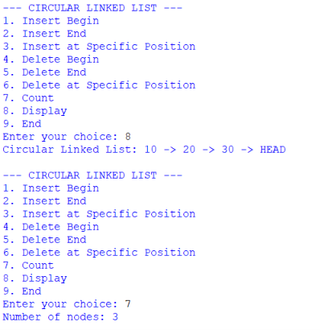
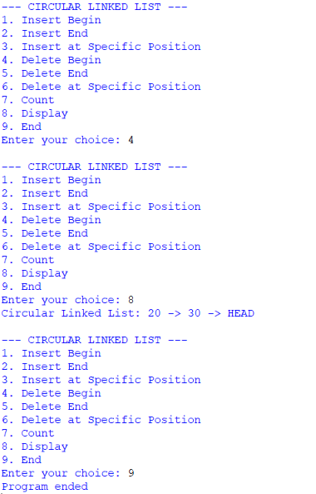
Explanation Of Codes:
A circular linked list is a linked list where the last node points back to the first node (head).
- Node: Stores data and next.
- Head: Points to the first node.
- Insert Begin: Adds a node before the current head.
- Insert End: Adds a node after the last node.
- Insert Position: Inserts a node at the given position.
- Delete Begin: Removes the first node and updates head.
- Delete End: Removes the last node.
- Delete Position: Removes a node from the specified position.
- Count: Counts all nodes by traversing the list.
- Display: Displays nodes until it reaches head again.
- End: Stops the program using break.

Error Table:
S.NO | Error Obtained | Rectification
1. | Forgetting to connect the last node to head. | Set the last nodes’s next = head.
2. | Deleting from an empty list | Check if self.head is None before deletion.
3. | Infinite loop during traversal. | Stop traversal when temp = = self.head.

PROGRAM | TIME COMPLEXITY |  |  | SPACE COMPLEXITY | REASON
1. Insert at Beginning |  |  |  |  | Finds the last node to update its link.
  O(n)
  O(1)
2.Insert at End |  |  |  |  | Traverse to the last node.
  O(n)
  O(1)
3.Delete at Beginning |  |  |  |  | Finds the last node.
  O(n)
  O(1)
4.Delete at End |  |  |  |  | Traverse to the second-last node
  O(n)
  O(1)
5.Delete by value
  O(n)
  O(1)
  Traverses to the specified position
6.Count Nodes | O(n) |  | O(1) |  | Visits every node
7.Display |  | O(n) | O(1) |  | Visits every node

WEEK-5

AIM:5a. Write a python program to implement a stack using an Array, Linked list. Implement the stack operations such as push, pop, peak and also display the stack elements.
Program:
Stack Using Array:
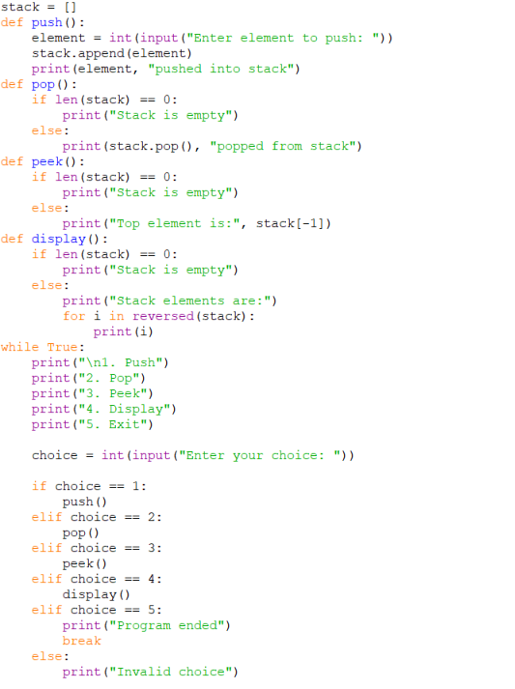

Output:
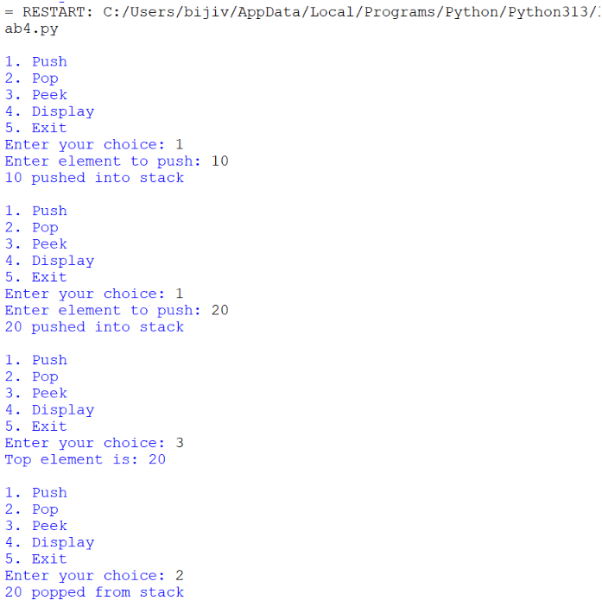
Error Table:
S.NO | Error Obtained | Rectification
1. | Trying to access stack[-1] when empty | Check whether stack is empty
2. | IndexError: pop from empty list - Trying to pop when stack is empty | Check len(stack) == 0 before pop
3. | Wrong display order - Elements displayed from bottom to top | Use reversed(stack)

Explanation Of Code:
stack = [] creates an empty list to store stack elements.
Push: append() adds a new element to the top of the stack.
Pop: pop() removes the top element from the stack.
Peek: stack[-1] displays the top element without removing it.
Display: reversed(stack) displays elements from top to bottom.
Empty check: len(stack) == 0 checks whether the stack is empty.
Menu: The while loop repeatedly displays the operations until the user selects Exit.

Stack Using Linked List:
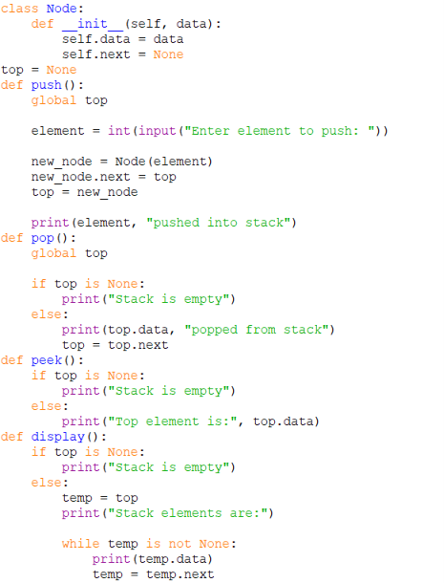
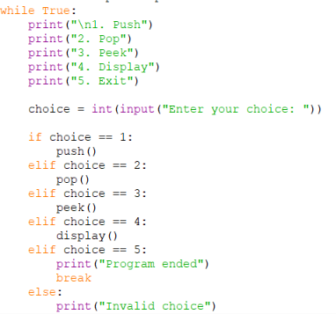
Output:
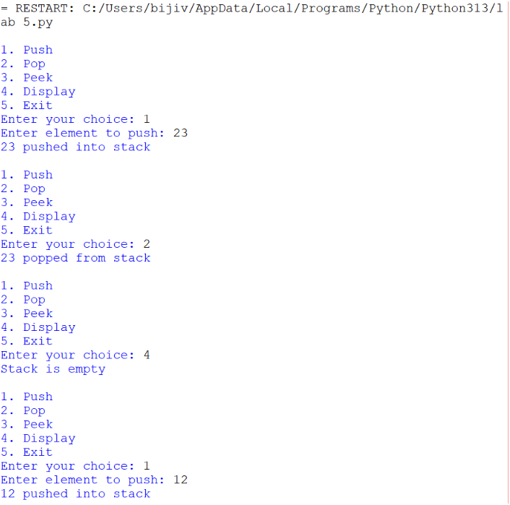

Error Table:
S.NO | Error Obtained | Rectification
1. | AttributeError - Accessing top.data when top is None | Check top is None
2. | Pop does not work - top is not updated | Use top = top.next
3. | Display gives wrong result - Temporary pointer is not moved | Use temp = temp.next

Explanation of Code:
Node class creates a node containing data and a next pointer.
top = None indicates that the stack is initially empty.
Push: A new node is created and connected before the current top. The new node becomes top.
Pop: The top node is removed by making top = top.next.
Peek: top.data displays the top element without removing it.
Display: A temporary pointer temp traverses the linked list and displays every element.
Empty check: top is None checks whether the stack contains any elements.
Menu: The while loop allows the user to repeatedly perform stack operations.

Lab-6
6a. AIM: Write a python program to implement queue and its operations such as enqueue, dequeue, peek, display with a menu driven approach implement using array, linked list.
PROGRAM: Using array
class QueueEx:
def __init__(self, size=5):
self.size = size
self.queue = [None] * size
self.front = -1
self.rear = -1

def enqueue(self, x):
if self.rear == self.size - 1:
print("Queue Overflow")
else:
if self.front == -1:
self.front = 0

self.rear += 1
self.queue[self.rear] = x
print(f"{x} inserted into the queue")

def dequeue(self):
if self.front == -1 or self.front > self.rear:
print("Queue Underflow")
else:
x = self.queue[self.front]
self.queue[self.front] = None
self.front += 1
print(f"{x} deleted from the queue")

if self.front > self.rear:
self.front = -1
self.rear = -1

def peek(self):
if self.front == -1:
print("Queue is empty")
else:
print("Front element:", self.queue[self.front])

def display(self):
if self.front == -1:
print("Queue is empty")
else:
print("The elements of the queue are:")
for i in range(self.front, self.rear + 1):
print(self.queue[i])

size = int(input("Enter the size of Queue: "))
q = QueueEx(size)

while True:
print("\n----- Queue Menu -----")
print("1. Enqueue")
print("2. Dequeue")
print("3. Peek")
print("4. Display")
print("5. Exit")

choice = int(input("Enter your choice: "))

if choice == 1:
item = int(input("Enter the element to enqueue: "))
q.enqueue(item)

elif choice == 2:
q.dequeue()

elif choice == 3:
q.peek()

elif choice == 4:
q.display()

elif choice == 5:
print("Exiting Program")
break

else:
print("Invalid choice")

output:-
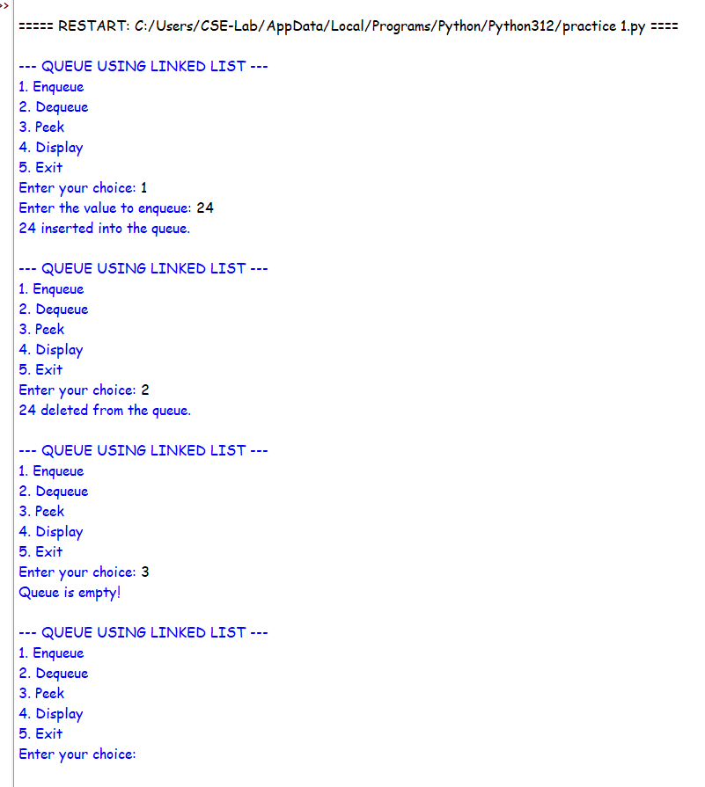

Error Table:
S.NO | Error Obtained | Rectification
1. | Queue Underflow / Error when deleting from an empty queue – front is None | Check if front is None before performing dequeue.
2. | Rear pointer remains incorrect after deleting the last element –  rear still points to the deleted node | After dequeue, check if front is None: and set rear = None.

PROGRAM: Using linked list:
class QueueEx:
def __init__(self, size=5):
self.size = size
self.queue = [None] * size
self.front = -1
self.rear = -1

def enqueue(self, x):
if self.rear == self.size - 1:
print("Queue Overflow")
else:
if self.front == -1:
self.front = 0

self.rear += 1
self.queue[self.rear] = x
print(f"{x} inserted into the queue")

def dequeue(self):
if self.front == -1:
print("Queue Underflow")
else:
x = self.queue[self.front]
self.queue[self.front] = None

print(f"{x} deleted from the queue")
self.front += 1

if self.front > self.rear:
self.front = -1
self.rear = -1

def peek(self):
if self.front == -1:
print("Queue is empty")
else:
print("Front element:", self.queue[self.front])

def display(self):
if self.front == -1:
print("Queue is empty")
else:
print("The elements of the queue are:")
for i in range(self.front, self.rear + 1):
print(self.queue[i])

size = int(input("Enter the size of Queue: "))
q = QueueEx(size)

while True:
print("\n----- Queue Menu -----")
print("1. Enqueue")
print("2. Dequeue")
print("3. Peek")
print("4. Display")
print("5. Exit")

choice = int(input("Enter your choice: "))

if choice == 1:
item = int(input("Enter the element to enqueue: "))
q.enqueue(item)

elif choice == 2:
q.dequeue()

elif choice == 3:
q.peek()

elif choice == 4:
q.display()

elif choice == 5:
print("Exiting Program")
break

else:
print("Invalid Choice!")

output:-
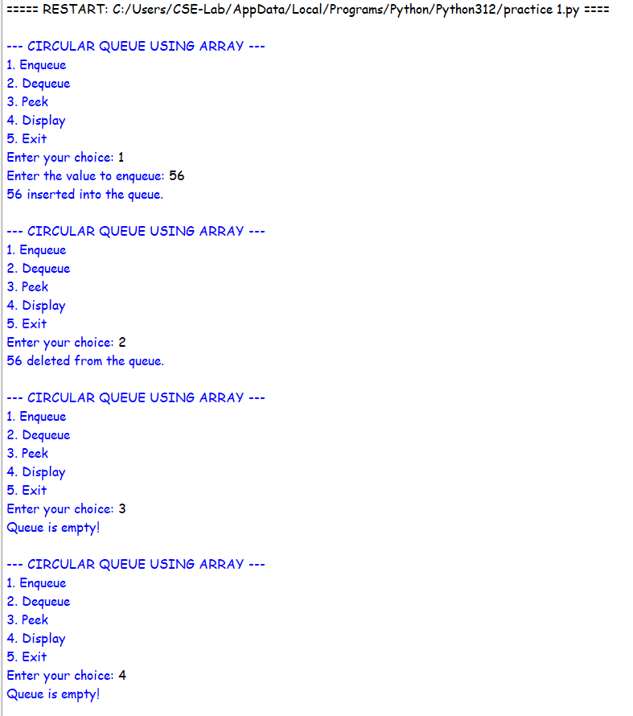

EXPLANATION:
· class QueueEx: Creates a class named QueueEx for implementing the queue.
· __init__(self, size=5): Constructor that initializes the queue with a default size of 5.
· self.size = size : Stores the user-given queue size.
· self.queue = [None] * size : Creates a list of the given size and initializes all positions with None.
· self.front = -1 : Initializes front to indicate that the queue is empty.
· self.rear = -1 : Initializes rear to indicate that no element is present.
enqueue()
· if self.rear == self.size - 1: Checks whether rear has reached the last position.
· self.front = 0 : Sets the front position when inserting the first element.
· self.rear += 1 : Increases rear to the next position.
· self.queue[self.rear] = x : Stores x at the rear position.
· print() : Displays the insertion message.
dequeue()
· if self.front == -1 or self.front > self.rear: Checks whether the queue is empty.
· x = self.queue[self.front] : Stores the front element in x.
· self.queue[self.front] = None : Removes the front element from the list.
· self.front += 1 : Moves front to the next position.
· if self.front > self.rear: : Checks whether all elements have been deleted.
· self.front = -1 and self.rear = -1 : Resets the queue to the empty state.
peek()
· if self.front == -1: Checks whether the queue is empty.
· self.queue[self.front] : Accesses and displays the front element without deleting it.
display()
· if self.front == -1: Checks whether the queue is empty.
· range(self.front, self.rear + 1) : Traverses the queue from front to rear.
· print(self.queue[i]) : Displays each queue element.
ERROR TABLE:
S.NO | Error Obtained | Rectification
1. | Queue Overflow occurs when the queue is full. | Check if self.rear == self.size - 1 before inserting an element.
2. | Queue Underflow occurs when the queue is empty.
  Check if self.front == -1 or self.front > self.rear before deleting an element.

6b. AIM: Write a python program to implement queue and its operations such as enqueue, dequeue, peek, display with a menu driven approach implement using circular linked list.

PROGRAM:
class Node:
def __init__(self, data):
self.data = data
self.next = None

class CircularQueue:
def __init__(self, size=5):
self.size = size
self.front = None
self.rear = None
self.count = 0

def enqueue(self, x):
if self.count == self.size:
print("Queue Overflow")
else:
new_node = Node(x)

if self.front is None:
self.front = new_node
self.rear = new_node
new_node.next = new_node
else:
new_node.next = self.front
self.rear.next = new_node
self.rear = new_node

self.count += 1
print(f"{x} inserted into the queue")

def dequeue(self):
if self.front is None:
print("Queue Underflow")
else:
x = self.front.data

if self.front == self.rear:
self.front = None
self.rear = None
else:
self.front = self.front.next
self.rear.next = self.front

self.count -= 1
print(f"{x} deleted from the queue")

def peek(self):
if self.front is None:
print("Queue is empty")
else:
print("Front element:", self.front.data)

def display(self):
if self.front is None:
print("Queue is empty")
else:
print("The elements of the queue are:")

temp = self.front

while True:
print(temp.data)
temp = temp.next

if temp == self.front:
break
size = int(input("Enter the size of Queue: "))
q = CircularQueue(size)

while True:
print("\n----- Queue Menu -----")
print("1. Enqueue")
print("2. Dequeue")
print("3. Peek")
print("4. Display")
print("5. Exit")

choice = int(input("Enter your choice: "))

if choice == 1:
item = int(input("Enter the element to enqueue: "))
q.enqueue(item)

elif choice == 2:
q.dequeue()

elif choice == 3:
q.peek()

elif choice == 4:
q.display()

elif choice == 5:
print("Exiting Program")
break

else:
print("Invalid Choice!")
OUTPUT:-
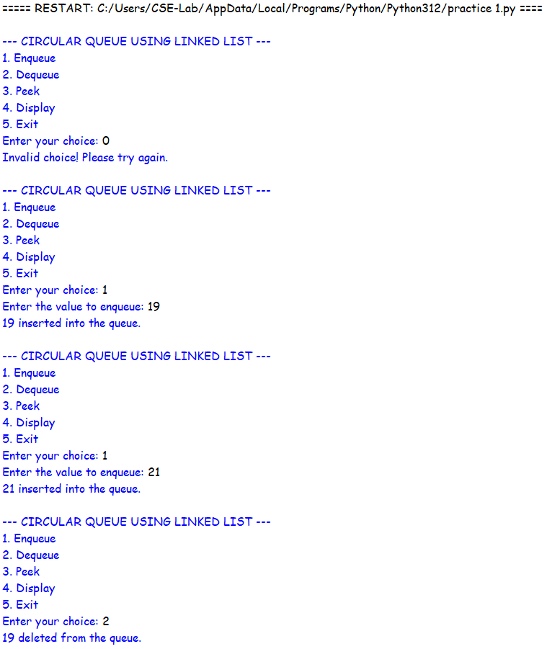

EXPLANATION:
1. Node Linking
· self.next = None : Initializes the node link as empty.
· new_node = Node(x) : Creates a new node with the given data.
· new_node.next = new_node : Makes the first node point to itself, forming a circular link.
2. Circular Connection During Enqueue
· new_node.next = self.front : Connects the new node to the first node.
· self.rear.next = new_node : Connects the current last node to the new node.
· self.rear = new_node : Updates the last node to the newly inserted node.
3. Circular Connection During Dequeue
· self.front = self.front.next : Moves front to the next node.
· self.rear.next = self.front : Reconnects the last node to the new front node.
· if self.front == self.rear: : Checks whether only one node exists.
· self.front = None : Removes the only node by clearing the front reference.
· self.rear = None : Clears the rear reference.
4. Circular Traversal
· temp = self.front : Starts traversal from the first node.
· temp = temp.next : Moves to the next linked node.
· if temp == self.front: : Detects that traversal has returned to the first node.
· break : Stops traversal after one complete circular cycle.
5. Node Data Access
· self.front.data : Accesses the data stored in the front node.
· temp.data : Accesses the data of the current node during traversal.

ERROR TABLE:
S.NO | Error Obtained | Rectification
1. | new_node.next is not connected to front, breaking the circular link | Set new_node.next = self.front.
2. | self.rear.next is not updated after insertion or deletion. | Update self.rear.next = new_node during enqueue and self.rear.next = self.front during deletion.

